# PL-900: Microsoft Power Platform Fundamentals

Power Apps

**Environment** – can be created from “Setting” -> “Admin Center”, then go to “Environments” on left menu. Click on + sign to create a new environment. Each environment consumes 1GB of space with or without Dataverse.

In environment, you can select “Region”. Select “Type” such as Production, Developer, Trial, Sandbox. Trial environment valid for 30 days and automatically remove after that. To set things up, you should:

1. Create an environment, define environment type
2. Add user to the environment
3. Assign permissions to the added user

**Security Roles** – Predefined security roles such as Environment Admin/Maker or create custom security roles.

**Dataverse** – can store business rules, not just storing the data. Business rules can be things like “trigger” if a record is stored in table or etc.

**Tables** – also called entities or objects. You have default tables and custom tables which can be also imported from unmanaged solutions (include customization created in dev env).

Read more at <https://learn.microsoft.com/en-us/power-platform/alm/solution-concepts-alm>

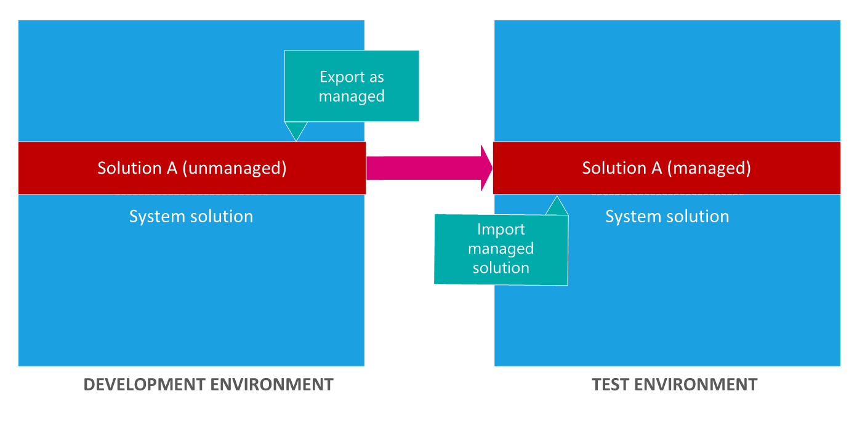

**Unmanaged solutions** are developed and **managed solutions** are deployed. Can’t edit managed solutions directly. If an unmanaged solution is deleted, all customizations will go under default solution and will not be removed. But if the managed solution is deleted, all customizations will be gone.

**Table types** – Standard, Activity (include actions such as Email), Virtual and Elastic

**Row ownership** – two types of row ownerships 1) own by user or team 2) own by organization.

**Table Relationship** – support three types: 1-Many, Many-1, Many-Many.

**Business Rule** – this was applied to Table. Business Rule allow us to add business logic. For example, if the user input value is something, then we can do something to some fields in the table. Some form of validation. Model driven app provides more options for business rule compared to Canvas app.

**Realtime workflow** – workflows are added to the solution. Go to solution and select the solution you want to add workflows. Workflow is located under Automation -> Process. Workflows are attached to tables (entity). Example, before or after a row status change in table, and such situation, we can add “Steps” to perform task. Steps can group into “Stages”. Tips: make sure to uncheck “run in background” if we want the workflow to run real-time.

**Actions** – Like workflow. The difference is action not required to attached to table. Action run based on something happened, such as workflow executed. Action provides messages which we can pass the variables and send to third parties, then process it and return value also can be captured in that action message.

**Dataflow** – allow to create a process. Many connectors to connect the data (such as Excel workbook or online data sources, on-prem resources need data gateway to connect). Useful to create ETL process using this. Example, extracting data from a data sources, transform it and load it back into warehouses.

**More on Dataverse table**

**Views** – each table has many views, and we can customize them, such as adding columns.

**Forms** – to input data into table. There are four different types of forms.

1. Main – you must have it for every table
2. Quick View – provides additional data from the table, e.g., detail view, display data
3. Quick Create – basic form to create new row, input data
4. Card – compact form usable for mobile devices serves same as Quick View

Power Automate

**Instant** – runs on demand on button press from power app or another place. e.g., notification.

**Automated** – runs based on system event, e.g., storing email attachment to One Drive.

**Scheduled** – runs on schedule., e.g., daily reminder email and this reoccurs.

Power Automate use triggers. Power App can be a source to make use of the Power Automate triggers.